HOME APPLIANCE CONTROL SYSTEM

Duk-Jin Kim
Jeff Dix
Jyotsna Kotur
Warren Pena
Yajing Zhao
Yasaman Haghpanah

October 12, 2006
Table of Contents
1. Introduction 3
2. Project Overview 3
3. Functional Requirement 4
4. Non-Functional Requirement 4
4.1 Adaptability 4
4.2 Safety 4
5. Use Case Diagram 4
5.1 Actors 5
5.2 Use Cases 6
6. Class Diagram 7
6.1 UML Class Diagram and Description 8
6.2 CRC Cards 9
7. Sequence Diagram 12
7.1 Authentication 12
7.2 Operate Garage Door 13
7.3 Operate TV 14
7.4 Operate Microwave 16

Introduction

A home appliance control system (HACS) is a system which provides various services to remotely operate on home appliances, such as microwave oven, TV, and garage door etc through remote devices such as mobile phone, desktop and palm-top. This document furnishes the Use Case diagrams, Class diagrams, and Sequence diagrams for the Home Appliance Control System using UML.

Project Overview

The Home appliance control system is controlled either by a cell phone or a by palm top or by a PC. They are connected either through wireless application protocol (WAP), the Internet, or intranet. It controls various appliances such as a microwave, TV etc. The HACS system receives commands from remote devices that are manipulated by user. The system in turn dispatch commands to respective appliances that will perform the actions. HACS is responsible for keeping track of the states of the devices. If something goes wrong, it will notify the user by sending messages back to the remote devices as well as emergency department if necessary.

The following picture gives an overview of how this system is going to work.

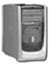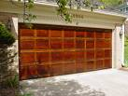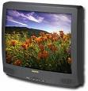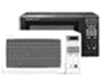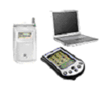

The system administrator of the HACS system has the ability to add a new appliance or delete an existing one. The system administrator has the ability to add a new remote device and configure it with HACS or delete an existing one when it is not used. Also the system administrator can create an account for a new user or delete existing account if it is no longer used.

Functional Requirement
A home appliance control system (HACS) is a system which is controlled by a remote system such as a mobile phone or a palm-top, and at the same time controls, monitors and coordinates home appliances such as air conditioner, microwave oven, garage doors, TV set, VCR, audio controller, indoor/outdoor lights, water sprinkler, home security system, bath tub controller, etc.

In order to activate home appliances and to allow for different ways of cooking, the HACS needs mechanisms for communication between the different devices in the system, and for coordination among the various processes running on such devices.

Note that the HACS needs mechanisms for adapting to different needs of the user as well. For example, when the user is very hungry, the microwave oven may need to respond to the user’s request that it operate maximally to cook the food as fast as it can. For another example, if the user is hungry, tired and may come home late, then the system may be asked to fully cook the meal by the expected arrival time, and periodic warming up every 10 minutes afterwards.

Non-Functional Requirement

Adaptability

The HACS shall be adaptable. Any change is environment shall be detectable, and the HACS shall then be transformable through recognition of the change in HACS needed and the change recognized shall be enacted in the system. The system could be automatically adaptable or manually adaptable. Since speed is of paramount importance for any real-time system, it shall be given a priority comparable to that of the adaptability requirement. This presumably according to the customer needs. Detecting changes in the environment is usually a very time-consuming task, hence hurting speed. Similarly, detection of events could induce significant performance penalty.

Safety
The HACS shall also be safe. For example, the microwave oven should now blow up or become too hot to touch.

Use Case Diagram

Use case diagrams are intended to model the functional requirements of the system. It shows a set of use cases and actors and their relationships. It is always selected to be the start point of software design. The following figure shows the use case diagram of the HACS system from the end user point of view.
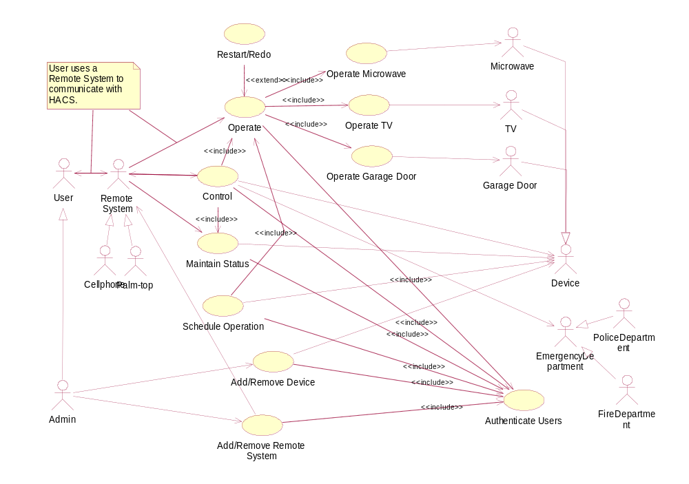

Actors

User
User refers to the person who has an account and a password, can log in on HACS, and operate home appliances remotely by HACS.

Admin
Admin is a kind of user who has special rights, for example Add/Remove Device and Add/Remove Remote System, other than basic operations.

Device
Device refers to computer embedded home appliances that could be added onto HACS, configured, and operated remotely.

TV
TV is a special home appliance that has several operations, such as turn on, turn off, increase volume, decrease volume, and change channel, which can be operated remotely.

Garage door
Garage door is a special home appliance that has operations of opening and closing to be manipulated remotely.

Microwave
Microwave is a special home appliance that has several operations, such as setting command, setting timer, starting, and so on, that can be operated remotely.

Remote System
Remote System refers to system that has wireless connection. It can be added onto HACS system, configured with HACS, and communicate with HACS.

Palm-top
Palm-top is a special remote system.

Cell phone
Cell phone is a special remote system.

Emergency Department
Emergency Department is a public department that can help if there is an emergency happens in the house.

Police Department
Police Department is a special emergency department which will be noticed when there is a break in through garage door.

Fire Department
Fire Department is a special emergency department which will be noticed when there is a fire in the house.

Use Cases

Operate
The use case Operate is a service provided for the users to operate on the devices that are connected to HACS through remote devices. For example, user can send messages of turning on a TV, starting microwave to cook for five minutes, and so forth to HACS and then HACS will perform the action.

Restart/Redo
The use case Restart/Redo is an extension of the use case Operate. When the HACS could not conduct the command that the user sent, it shall detect and fix the error or restart the device to make it function normally. And the operation will be conducted once more. Besides, the HACS shall inform the user about this exception.

Operate Microwave
The use case Operate Microwave is a service provided for the users to operate on the microwave that is connected to HACS through remote systems. Users can send messages of cooking, defrosting, stopping, etc.
Operate Garage Door
The use case Operate Garage Door is a service provided for the users to operate on the garage door that is connected to HACS through remote systems. Users can send messages of opening and closing it.

Operate TV
The use case Operate TV is a service provided for the users to operate on the TV that is connected to HACS through remote systems. Users can send messages of turning it on, turning it off, increasing the volume, decreasing the volume, and changing channels.

Check/Update Status
The use case Check/Update Status means that the HACS keeps a record of the state of all the connected devices. It keeps updating their states from time to time. When users require the state information of some device through remote systems, the HACS send the latest state of that device to the remote system that requested.

Control
Sometimes the device may malfunction. For example, the microwave may keep cooking for an hour, which is not required by the users. The use case Control means it can detect such malfunctioning by updating the state of the devices, stop it (using operate use case), and inform the user what happened. Another case there might be some emergency happens, for example, a break in through the garage door or fire starts, the HACS shall detect them and notify police department and fire department respectively.

Add/Remove Device
The use case Add/Remove Device is a service for the users to add a device, for example, microwave, TV, and garage door, onto the HACS to be controlled remotely and automatically, as well as remove a device from the HACS that is no longer to be controlled. When a device is connected to HACS, both the HACS and the device are configured in order to collaborate with each other.

Add/Remove Remote System
The use case Add/Remove Remote System is a service for the users to add or remove a remote control system, for example, cell phone and palm-top, onto the HACS, so that the remote system can be used to communicate with the HACS and control the devices.

Class Diagram

UML Class Diagram and Description
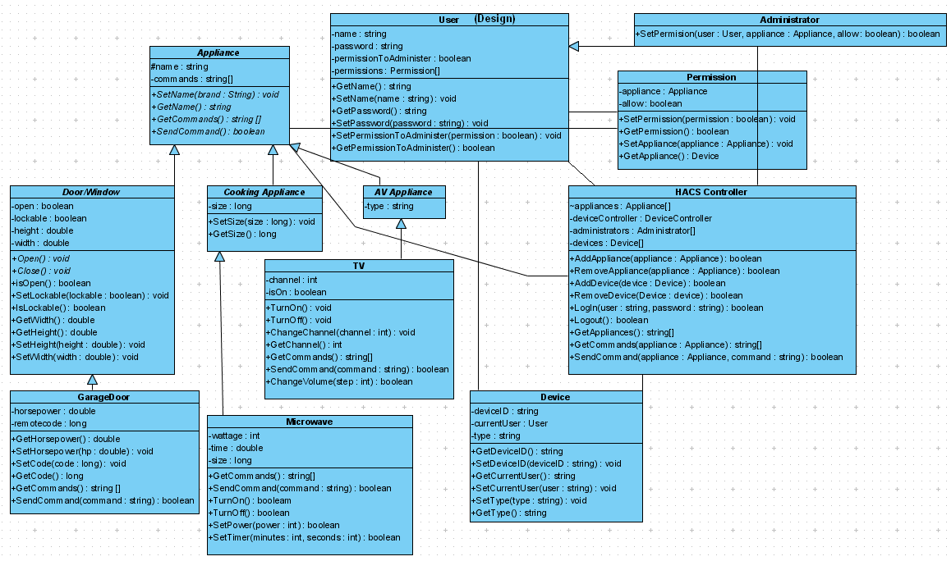

Appliance Class
The Appliance class shall act as a common parent class to all of the different types of appliances. The use of a common parent class allows for a certain interface between the HACS controller and the appliances to be enforced. Enforcing a common interface ensures that the entire system does not need to be recompiled to add a device to the system, but rather that appliances can be added or removed from the system dynamically simply by adding the appliance’s compiled class file to the system’s directory and then instructing the system to add the appliance to the system.

Door/Window, Cooking Appliance, and AV Appliance Class
The Door/Window, Cooking Appliance, and AV Appliance classes serve as an example of the appliance type layer of classes. These classes will directly inherit from the Appliance class, but will not themselves represent physical appliances. Rather, this layer serves to enforce a common interface and common properties among a given type of appliance.

Garage Door, Microwave, and Device Classes
The GarageDoor, Microwave, and Device classes are examples of the classes the represent actual physical appliances. These classes inherit from their respective appliance type class, and thus from the Appliance class. These classes will contain the actual implementation of the appliance function. Because all these classes inherit from the same Appliance class, all can be indexed by the HACS system and can be sent commands in the same manner.

HACS Controller Class
The HACS controller class is the heart of the system. This is the class that controls appliances, devices, and users. The HACS controller contains an array of appliances, which is the list of all of the appliances on the system. A command can be sent to an appliance simply by calling that appliance’s SendCommand(string) method. Each Appliance’s SendCommand(string) method can interpret the command embedded in the string parameter, and will call the appropriate internal methods. And Appliance’s GetCommands() method returns a list of all of the valid commands for that Appliance, which can then be passed up to the user. The HACS Controller class also handles interaction between the system and remote devices, and it handles the users logging in and out of the system. In addition, it handle adding and removing users and devices to/from the system.

Device Class
The Device class represents a physical device used to remotely administer the system. It contains information on the device itself and the user currently using the device.

User Class
The User class represents a user. It contains the user’s name and password, whether or not the user has permission to administer the system, and an array of Permissions, indicating which appliances the user may or may not control.

Administrator Class
An instance of the permission class contains one link between a user and an appliance and indicates whether or not that user is allowed to use that appliance.

Permission Class
An instance of the permission class contains one link between a user and an appliance and indicates whether or not that user is allowed to use that appliance.

CRC Cards

HACS Controller
HACS Controller
RESPONSIBILTIES | COLLABORATORS
- allow user to login and logout.  - add appliances or remove appliances  - request for states of appliances  - send commands to appliances to execute  - get appliances that are connected to HACS | User  Administrator  Appliance  Device

User
User
RESPONSIBILTIES | COLLABORATORS
- get name and password of the user  - set name and password of the user  - set permission to become an administrator  - get whether the user is an administrator | HACS Controller  Permission  Device

Administrator
Administrator
RESPONSIBILTIES | COLLABORATORS
- get name and password of the user  - set name and password of the user  - set permission to become an administrator  - get whether the user is an administrator  - set access permission of a user to an appliance | HACS Controller  Permission  Device

Appliance
Appliance
RESPONSIBILTIES | COLLABORATORS
- get name of the appliance  - set name of the appliance  - get current command (state) the appliance is executing  - execute a command | HACS Controller  Permission

Door/Window
Door/Window
RESPONSIBILTIES | COLLABORATORS
- get name of the appliance  - set name of the appliance  - get current command the appliance is executing  - get current state (open or closed)  - set attributes, i.e. height and weight  - execute a command | HACS Controller  Permission

Cooking Appliance
Cooking Appliance
RESPONSIBILTIES | COLLABORATORS
- get name of the appliance  - set name of the appliance  - get current command (state) the appliance is executing  - execute a command  - set attributes of the appliance, i.e. size  - get attributes of the appliance | HACS Controller  Permission

AV Appliance
AV Appliance
RESPONSIBILTIES | COLLABORATORS
- get name of the appliance  - set name of the appliance  - get current command (state) the appliance is executing  - execute a command | HACS Controller  Permission

Garage Door
Garage Door
RESPONSIBILTIES | COLLABORATORS
- get name of the appliance  - set name of the appliance  - get current command the appliance is executing  - get current state (open or closed)  - set attributes, i.e. height and weight  - execute a command  - set horsepower of the garage door  - get horsepower of the garage door | HACS Controller  Permission

Microwave
Microwave
RESPONSIBILTIES | COLLABORATORS
- get name of the appliance  - set name of the appliance  - get current command (state) the appliance is executing  - execute a command  - set attributes of the appliance, i.e. size  - get attributes of the appliance  - turn on/off the microwave  - set power of the microwave  - set timer for the microwave | HACS Controller  Permission

TV
TV
RESPONSIBILTIES | COLLABORATORS
- get name of the appliance  - set name of the appliance  - get current command (state) the appliance is executing  - execute a command  - turn on/off the TV  - change channel/volume  - get current channel/volume | HACS Controller  Permission

Device
Device
RESPONSIBILTIES | COLLABORATORS
- get device id  - set device id  - get current user of the device  - set user of the device  - get type of the device  - set type of the device | HACS Controller  User

Permission
Permission
RESPONSIBILTIES | COLLABORATORS
- set permission of a user to a particular appliance  - get the permission status of a user to an appliance | User  Appliance  HACS Controller

Sequence Diagrams
To operate the HAC System, user needs to operate each home appliance either by direct contact or by a remote control system. Sequence Diagram will explain the operation by a remote control system. To connect to the remote system, user needs computer embedded communication devices such as a cell phone, a PDA, or a laptop computer.

Authentication

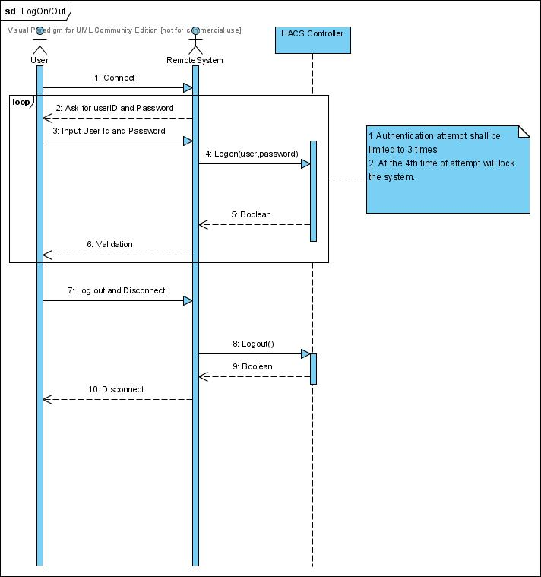

Flow of events:
- After user connects the remote system, user needs to log on to the system using valid username and password.
  - A logon attempt shall limited to 3 times for security precaution.
- After all use of the system, user shall log out the system and communication between user and remote system is disconnected.

Operate Garage Door

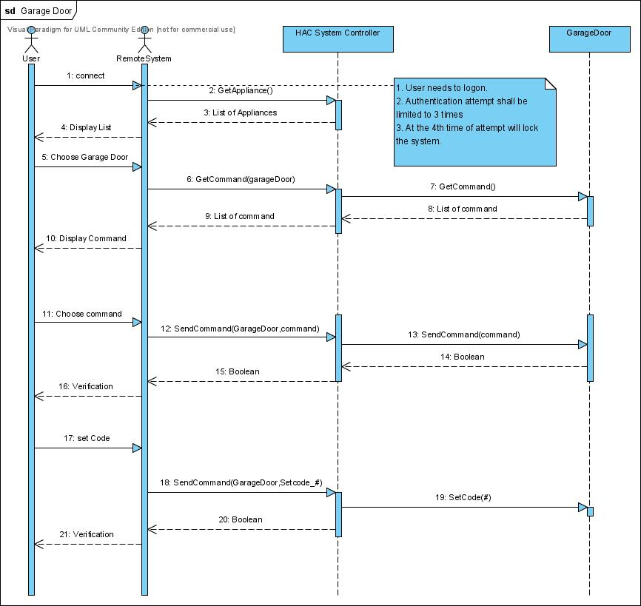

Flow of events:
- After user log onto the system, remote system asks HACS controller a list of appliances.
- User simply chooses the garage door from the appliance list.
- Remote system asks the command list of a garage door.
- HACS controller asks a garage door a list of commands.
- A garage door returns the list of commands to the HACS controller then HACS controller returns the list to the remote system, then remote system displays the command list
- User chooses one of command list and HACS controller do the operation.

Operate TV

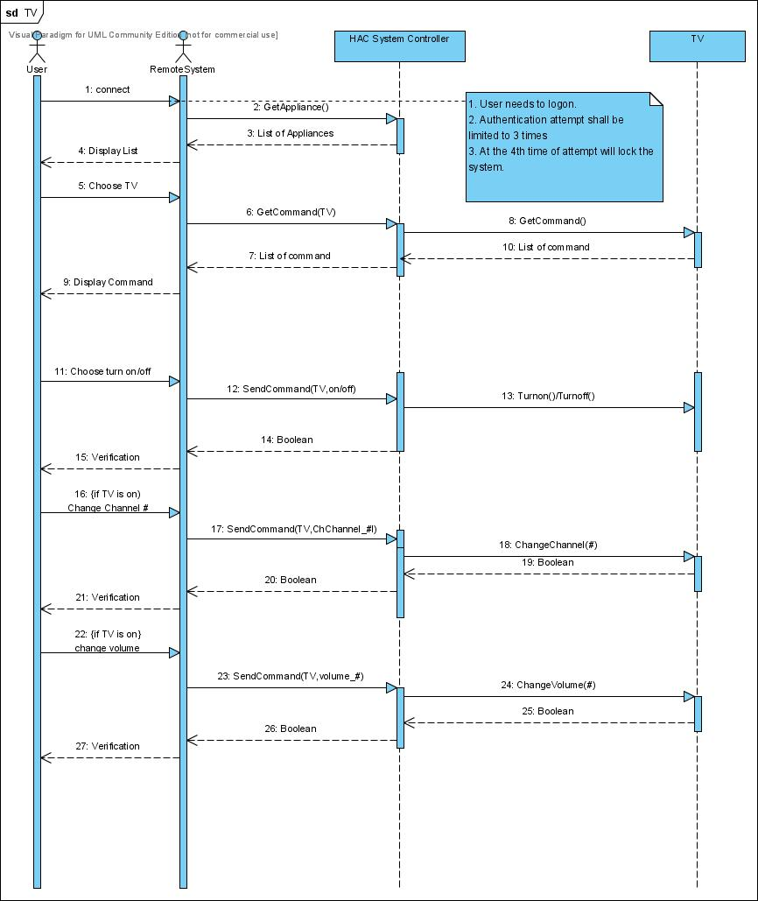

Flow of events:
- After user log onto the system, remote system asks HACS controller a list of appliances.
- User simply chooses the TV from the appliance list.
- Remote system asks the command list of a TV.
- HACS controller asks a TV a list of commands.
- A garage door returns the list of commands to the HACS controller then HACS controller returns the list to the remote system, then remote system displays the command list
- User chooses one of command list and HACS controller do the operation.

Operate Microwave

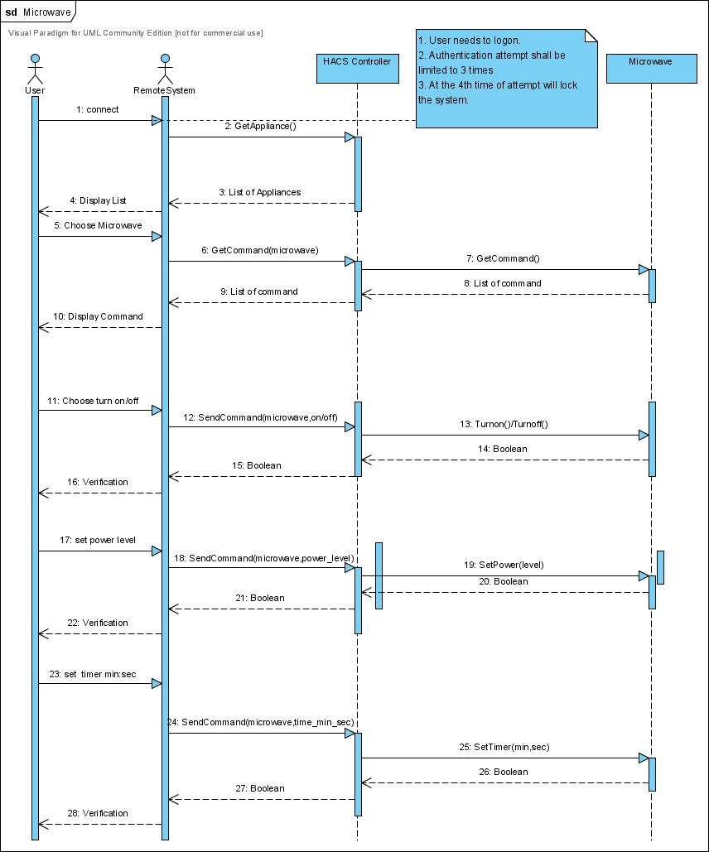

Flow of events:
- After user log onto the system, remote system asks HACS controller a list of appliances.
- User simply chooses the microwave from the appliance list.
- Remote system asks the command list of a microwave.
- HACS controller asks a microwave a list of commands.
- A garage door returns the list of commands to the HACS controller then HACS controller returns the list to the remote system, then remote system displays the command list
- User chooses one of command list and HACS controller do the operation.

